Speaker Bios

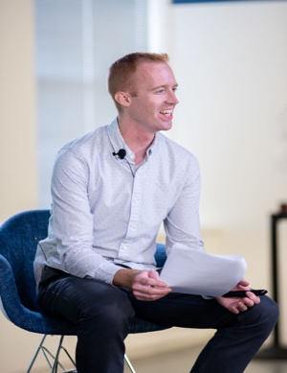
Brendan Neuman, PhD

Brendan Neuman has developed, designed, and implemented a variety of leadership assessment tools to provide sensible, practical solutions for his clients, with a particular emphasis on drawing out the innovative and creative talents already present among the leaders with whom he works.
Brendan founded his own boutique consultancy through which he provides assessment, leadership development, and innovation consulting. Earlier in his career, Brendan served in a variety of talent management and talent acquisition roles at United Airlines. He later served as a senior director of psychology, product research, and design at the global consulting firm Heidrick & Struggles where he designed and improved upon the firm’s leadership assessment products. His areas of expertise include executive and high-volume assessment, HR analytics, leadership development and organizational creativity.
He has designed and deployed 360-degree feedback systems, assessment centers, simulations, and executive assessments for organizations in the public, private and not-for-profit sectors across industries including technology, financial services, transportation and logistics, utilities, consumer package goods, retail, and telecommunications. He has supported leaders and teams in organizations ranging in size from small businesses and start-ups to large multi-national organizations, and in countries around the globe.
In addition to his consulting work, Brendan has served as an adjunct faculty member at various universities. He has designed classes in organizational psychology, statistics, and the psychology of creativity. He also provides pro bono consulting to Chicago area arts organizations through the Arts & Business Council of Chicago.
Brendan earned his PhD and MS in Industrial/Organizational Psychology from the Illinois Institute of Technology in Chicago, IL and a BS in Psychology from Northern Illinois University in DeKalb, IL.

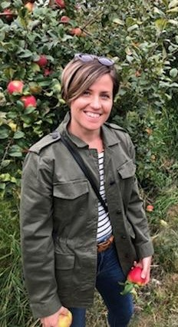

Morgan Gleason Miller

Morgan Gleason Miller began her career in accounting in upstate New York/New Jersey. After gaining experience in the public and private sectors, she decided to pursue a career in Psychology in the hopes of changing the systems she spent her days tracking. Upon earning her master’s in Psychology at SUNY New Paltz she became an adjunct professor and lecturer. She especially enjoys teaching Social Psychology because she places value on helping students understand themselves and recognize (and contend with) their susceptibility to interpersonal bias and social influence. Social Psychology facilitates active discussion and interaction, which she feels is necessary to help students contextualize and integrate material effectively. This dynamic fits Morgan’s teaching philosophy and her enthusiastic interpersonal style.

In 2018, Morgan began her Ph.D. journey in Industrial-Organizational Psychology at DePaul. Since then, Morgan has analyzed HR data to develop a leader succession plan and provide guidance for improving diversity in leadership at a food science company. As part of DePaul team projects, she designed and implemented (the first module) of a training curriculum for employees within the insurance brokerage industry and developed a career services and mentoring program for a private university in Chicago.
Morgan’s research has focused on using a social network approach to understand team performance. She is currently working with military officers on a cross-cultural research team examining how virtual communities meet the needs of women in the military and foster organizational change. Her dissertation involves conducting a systematic review of the social network analysis literature to evaluate whether researcher gender and discipline of study influence how variables are defined, measured, and interpreted. She is passionate about auditing leadership selection and appraisal systems to remove barriers to women’s advancement in the workplace, improving DE&I initiatives, and evaluating and coaching leaders.

